**Lab#4(a) a. Implement OOP concepts with PHP for following program:**

**Use Student, Teacher and Subject Class to define relation between each of them. Display the details of**

**the student studying a particular subject under a particular teacher. Use Constructors and**

**Polymorphism.**

**Final Outcome:**

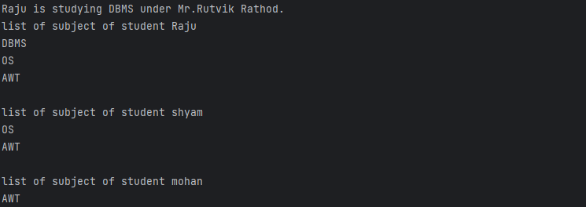

**Code Snippet:**

<?php

class Subject{

public $name;

public function __construct($name)

{

$this->name=$name;

}

}

class Person{

public $name;

public function __construct($name)

{

$this->name=$name;

}

}

class Student extends Person{

public $subjects=array();

public function addSubject($subject)

{

$this->subjects[]=$subject;

}

}

class Teacher extends Person{

public $subject;

public function __construct($name,$subject){

parent::__construct($name);

$this->subject=$subject;

}

}

$dbmsSubject=new Subject("DBMS");

$osSubject=new Subject("OS");

$awtSubject=new Subject("AWT");

//create Teachers

$dbmsTeacher=new Teacher("Mr.Rutvik Rathod",$dbmsSubject);

$awtTeacher =new Teacher("Mr.Shubham Solanki",$awtSubject);

$osTeacher=new Teacher("Mr.Baburao Aapte",$osSubject);

//Creating Student objects

$student1=new Student("Raju");

$student2=new Student("shyam");

$student3=new Student("mohan");

$student1->addSubject($dbmsSubject);

$student1->addSubject($osSubject);

$student1->addSubject($awtSubject);

$student2->addSubject($osSubject);

$student2->addSubject($awtSubject);

$student3->addSubject($awtSubject);

$selectedStudent = $student1;

$selectedSubject = $selectedStudent->subjects[0];

if($selectedSubject===$dbmsSubject)

$selectedTeacher=$dbmsTeacher;

else if($selectedSubject===$osSubject)

$selectedTeacher=$osTeacher;

else

$selectedTeacher=$awtTeacher;

echo "{$selectedStudent->name} is studying {$selectedSubject->name} under {$selectedTeacher->name}.";

echo "\nlist of subject of student ".$student1->name."\n";

for($i=0;$i<count($student1->subjects);$i++)

print_r($student1->subjects[$i]->name."\n");

echo "\nlist of subject of student ".$student2->name."\n";

for($i=0;$i<count($student2->subjects);$i++)

print_r($student2->subjects[$i]->name."\n");

echo "\nlist of subject of student ".$student3->name."\n";

for($i=0;$i<count($student3->subjects);$i++)

print_r($student3->subjects[$i]->name."\n");?>